**INTEL UNNATI INDUSTRIAL TRAINING – SUMMER 2023**

**NITTE MEENAKSHI INSTITUTE OF TECHNOLOGY**

**PROBLEM STATEMENT: ACCIDENT LOCATION ON INDIAN ROADS**

**DATE** : 14.07.2023

**TEAM NAME**: INTEGRATED WINGS

**INSTITUTION MENTOR**: DR.RAJESH N

**INDUSTRY MENTOR:** ABHISHEK NANDY

**TEAM MEMBERS**: NEEHARIKA MADHU SOODAN ,KIRTHI PRABHAKAR AND NAGA SATHWIKA B

# ABSTRACT:

## Introduction :

In India, a substantial number of individuals endure the loss of their lives and belongings in road accidents, resulting in substantial economic losses. These incidents also result in significant emotional and psychological anguish, as well as a sense of insecurity and enduring problems for the victims and their households. In many cases, these accidents occur without the fault of the victims or their families. Moreover, these accidents cause irreversible harm to the country in the form of damages, incapacitations, and demoralizing consequences for the victims and their households. The 3 E's of road safety, namely, education, engineering, and enforcement, play a crucial role in reducing the number of road accidents. To effectively identify and implement measures aimed at reducing these accidents, it is essential to analyze road traffic scientifically. This involves the identification of dangerous areas or roads, the implementation of necessary corrections, and the development of effective policies for education and enforcement. Our team is committed to conducting in-depth scientific studies to identify and comprehend accident-prone roads and regions in Karnataka. Our aim is to discover appropriate solutions to enhance traffic

## Analysis of accidents from the collected data:

1. Residential and open areas have a higher rate of accident occurrences compared to commercial or market locations.
2. Straight roads, rather than curved ones, are more likely to witness accidents.
3. Common factors that increase the risk of traffic accidents include the steepness of grades, unfinished roadways, and the presence of potholes.
4. Junctions with a T or Y configuration are more prone to accidents, followed by four-arm and round junctions.
5. Traffic light-controlled zones are commonly associated with increased accident rates, while police-controlled zones are not.
6. Sunny or clear weather conditions are associated with an increased risk of traffic accidents.
7. Two- wheeled vehicles, such as bikes and scooters, are the primary contributors to traffic accidents, followed by pedestrians and cars, taxis, and vans.

## Our approach to solve the problem :

This project aims to analyze the geographical distribution of accidents on Indian roads using spatial data analysis techniques. The study aims to identify potential contributing factors and patterns associated with road traffic accidents (RTAs), with the intention of formulating recommendations for effective road safety interventions and strategies for reducing their incidence. The study was conducted in two phases: a literature review and a field survey. The literature review will analyze existing literature on traffic accidents, including the causes of accidents and the methods used to identify accident locations. The field survey will collect data on the location and characteristics of traffic accidents on selected routes in Indian cities. The data will be collected from police reports and interviews with traffic police officers. Once the data is collected, it will be analyzed using spatial analysis techniques such as hot spot mapping and kernel density estimation.

To analyze and evaluate the accident location data on Indian roads here, we have used QGIS (Quantum Geographic Information System). Utilizing the OpenStreetMap (OSM) dataset, the project will extract information about road features such as speed limits, lane widths, and the presence of traffic signals. This information is then overlaid with the accident data from the Traffic Management Centre (TMC) of India, allowing us to analyze the relationship between road characteristics and accident occurrence. The statistical analysis was conducted using various tools within QGIS, such as regression analysis and hot spot identification. The findings of this study is presented through graphs, maps, and reports, providing insights into the underlying factors contributing to RTA

## Working :

Here, we have used QGIS to map the accident locations taking Bangalore road accidents in 2021 from the information according to the Ministry of road transport and highways. We have also used the Severity index to calculate the data[Accident severity index (ASI) value]. The identification of black spots can help in better scheduling road safety policies. Severity index method was used for finding the hotspots. Based on the data collected, the Accident Severity Index (ASI) value was calculated. The blackspots were prioritized according to the severity of the location and road safety analysis was done in the identified hotspots.

ASI = NfWf + NsWs + NmWm

Where, Nf =No. of fatal accidents at the spot in the last 3 years; Wf=Weight assigned to fatal accident=6; Ns=No. of serious accidents at the spot in the last 3 years; Ws=Weight assigned to serious accident=3; Nm=No. of minor accidents at the spot in the last 3 years ;Wm=Weight assigned to minor accident=1

For each location the equation was applied and calculated. After obtaining those severity values the hotspots were ranked according to these values

The hotspots thus obtained are marked using QGIS software. Hot spots were located by using latitude and longitude of a place. Here each hotspot was labeled with its corresponding name and shape files were cut.The data as well as mapping can be seen here

FIGURE 2 : Black spots mapping of Bangalore

FIGURE 1: Black spots mapping of Karnataka

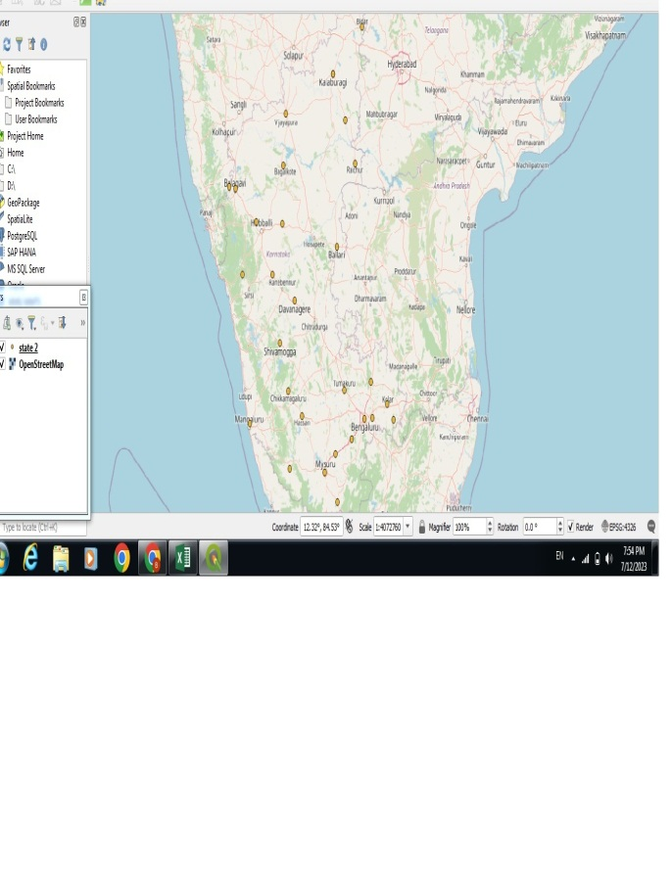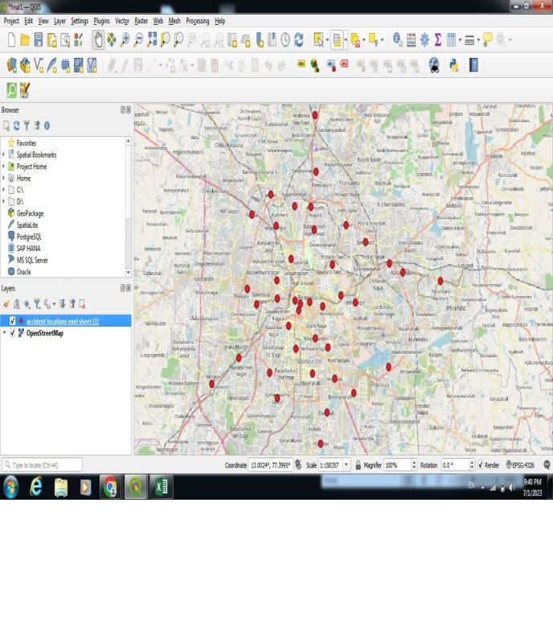

|  |  |  |
| --- | --- | --- |
| RANK | BLACK SPOTS OF KARNATAKA | BLACK SPOTS OF BANGALORE |
| 1 | Bengaluru city | Yelahanka |
| 2 | Tumakuru | chikkajala |
| 3 | Bengaluru district | Devanahalli |
| 4 | Hassan | Kamakshi palya |
| 5 | Mandya | Kumaraswamy layout |
| 6 | Belagavi district | Peenya |

# RESULT:

We have done the analysis and mapping of accident locations for Karnataka and Bangalore in specific using QGIS. We can avoid major occurring accidents by following the traffic rules and being a responsible driver.

The study was an attempt to find out the black spots in Karnataka and Bengaluru. The Accident Severity Index (ASI) method was used to rank the accident locations. This method was found to be effective in identifying the blackspots. As the result is given in map format, it is easy to interpret result. Based on the analysis, Bengaluru city has highest number of data and in Bengaluru,Yelahanka was identified as most vulnerable accident prone area .Road Site safety analysis was conducted at all the hotspots to know the condition of the road. Road Safety analysis can be used to find out factors influencing crashes and hence to give remedial measures

# ACKNOWLEDGEMENT:

We would like to express our sincere gratitude to the Intel organization, the management of our institution, our mentors, and everyone who played a part in enabling us to embark on this journey of exploring and immersing ourselves in Geographic Information System (GIS) tools and accident mapping. Additionally, we would like to acknowledge the acquisition of valuable skills in time management, patience, and much more which was all possible through this project .We look forward to doing more for the society.

# URL :

<https://ksp.karnataka.gov.in/storage/pdf-files/Road_Accident_Report_2021.pdf>

<https://morth.nic.in/road-accident-in-india>